Algorithms Data Structures

- Exercise 1: Inventory Management System:
Scenario: You are developing an inventory management system for a warehouse. Efficient data storage and retrieval are crucial.
Output:

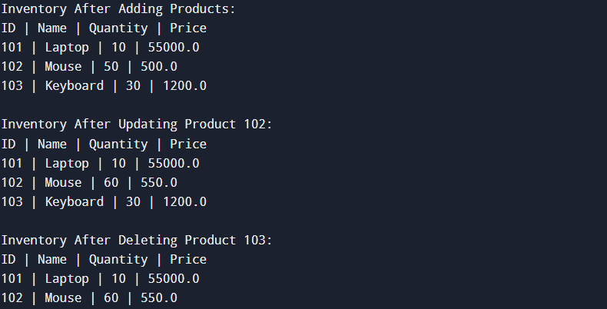

- Exercise 2: E-commerce Platform Search Function
Scenario: You are working on the search functionality of an e-commerce platform. The search needs to be optimized for fast performance.
Output:



- Exercise 3: Sorting Customer Orders
Scenario: You are tasked with sorting customer orders by their total price on an e-commerce platform. This helps in prioritizing high-value orders.
Output:


- Exercise 4: Employee Management System
Scenario: You are developing an employee management system for a company. Efficiently managing employee records is crucial.
Output:

- Exercise 5: Task Management System
Scenario: You are developing a task management system where tasks need to be added, deleted, and traversed efficiently.
Output:



- Exercise 6: Library Management System
Scenario: You are developing a library management system where users can search for books by title or author.
Output:



- Exercise 7: Financial Forecasting
Scenario: You are developing a financial forecasting tool that predicts future values based on past data.
Output:



